Minh Duc Nguyen

ID: 2069407

**Assignment 2**

1. **Two linear lists of size n**
2. Lower bound

Assume two matrices are given are A and B. In order to check if any element of A is an element of B, we would have to iterate through every single one in list A (n times), then check each element with list B (n times). So, as we can see, the lower bound complexity would be O(n^2).

1. Algorithm

* First, we copy matrix A to a new matrix C

for (int i = 0; i < n; i++)

for (int j = 0; j < n; j++)

C[i][j] = A[i][j]

* Modify matrix B by increasing each element by 1

for (int i = 0; i < n; i++)

for (int j = 0; j < n; j++)

B[i][j] += 1

* We can check if there are any changes in any of the elements in matrix A by comparing it with matrix C. If matrix A is equal to matrix C, then A and B don’t share the same memory space and vice versa.

for (int i = 0; i < n; i++)

for (int j = 0; j < n; j++)

if (C[i][j] != A[i][j])

break

* Return B to its original state

for (int i = 0; i < n; i++)

for (int j = 0; j < n; j++)

B[i][j] -= 1

There are 4 nested for loops, and the time complexity is O(4n^2) = O(n^2).

1. **On-line median**

The find function can be improved by making the insert/delete function to shift the nodes according to the value of k (n/4). The insert/delete functions are implemented just like the AVL tree method discussed in class but with a shiftNode function at the end of each insert/delete function.

* *Algorithm:*

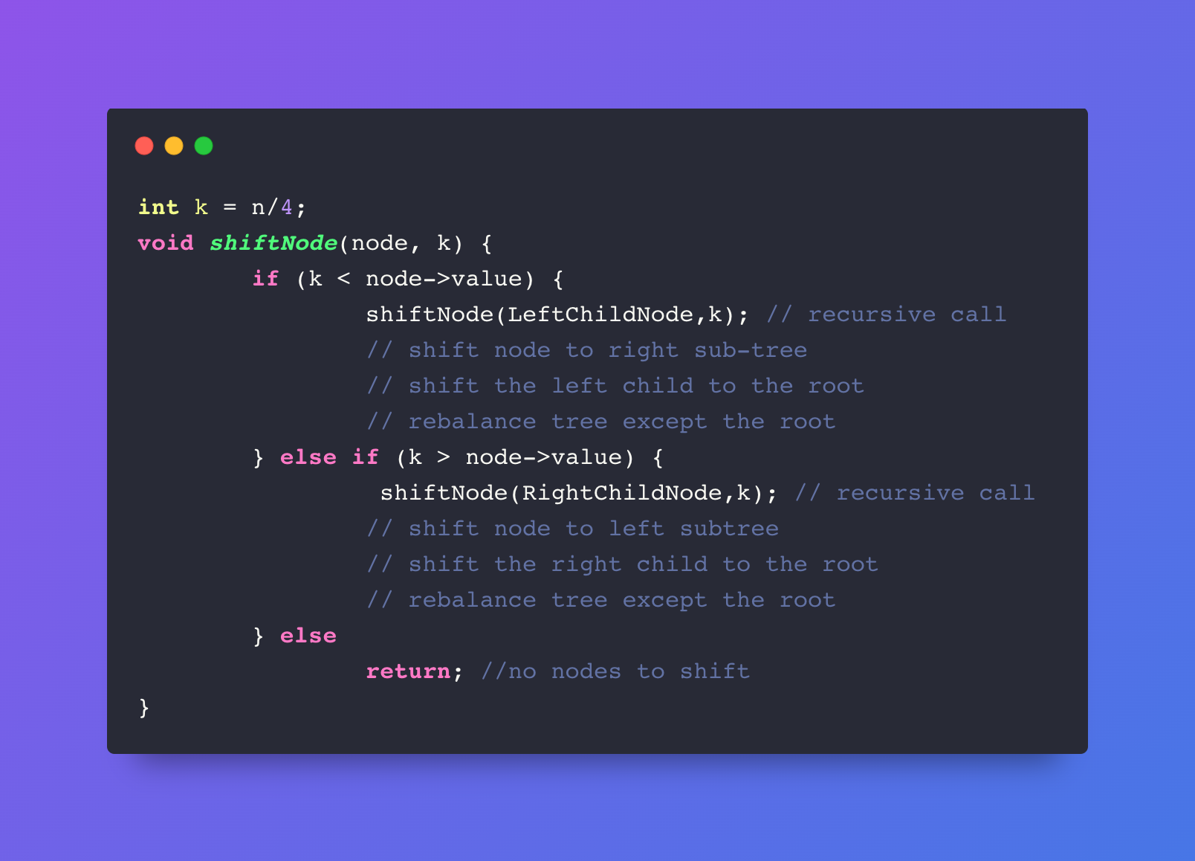

The insert/delete function will be a bit slower than O(log2n). However, the find function now has a time complexity of O(1), since it only has to directly access the root of the tree to get the value which is better than the previous time complexity of O(log2n). The space complexity for the insert/delete functions are still the same at O(log2n) while the find function would also have the same complexity at O(1).

1. **Multiplying rectangular matrices**

First, we will construct the n x n matrix that was used from the textbook. The average work of multiplying n matrices would be equal to the total sum of the scalar multiplications of the k values described from the textbook divided by the total number of k-values used in the operation.

From the textbook, we calculate the k-value as:

S[i,j] = ni+nk+1+nj+1+S[i,k]+S[k+1,j]

*- Algorithm*

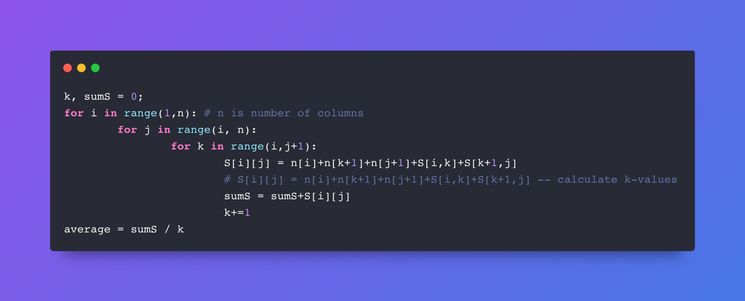

The time complexity would be O(n^3) because of the 3 nested for loops while the space complexity is O(n^2).

1. **Algorithm on p. 126**

Code:

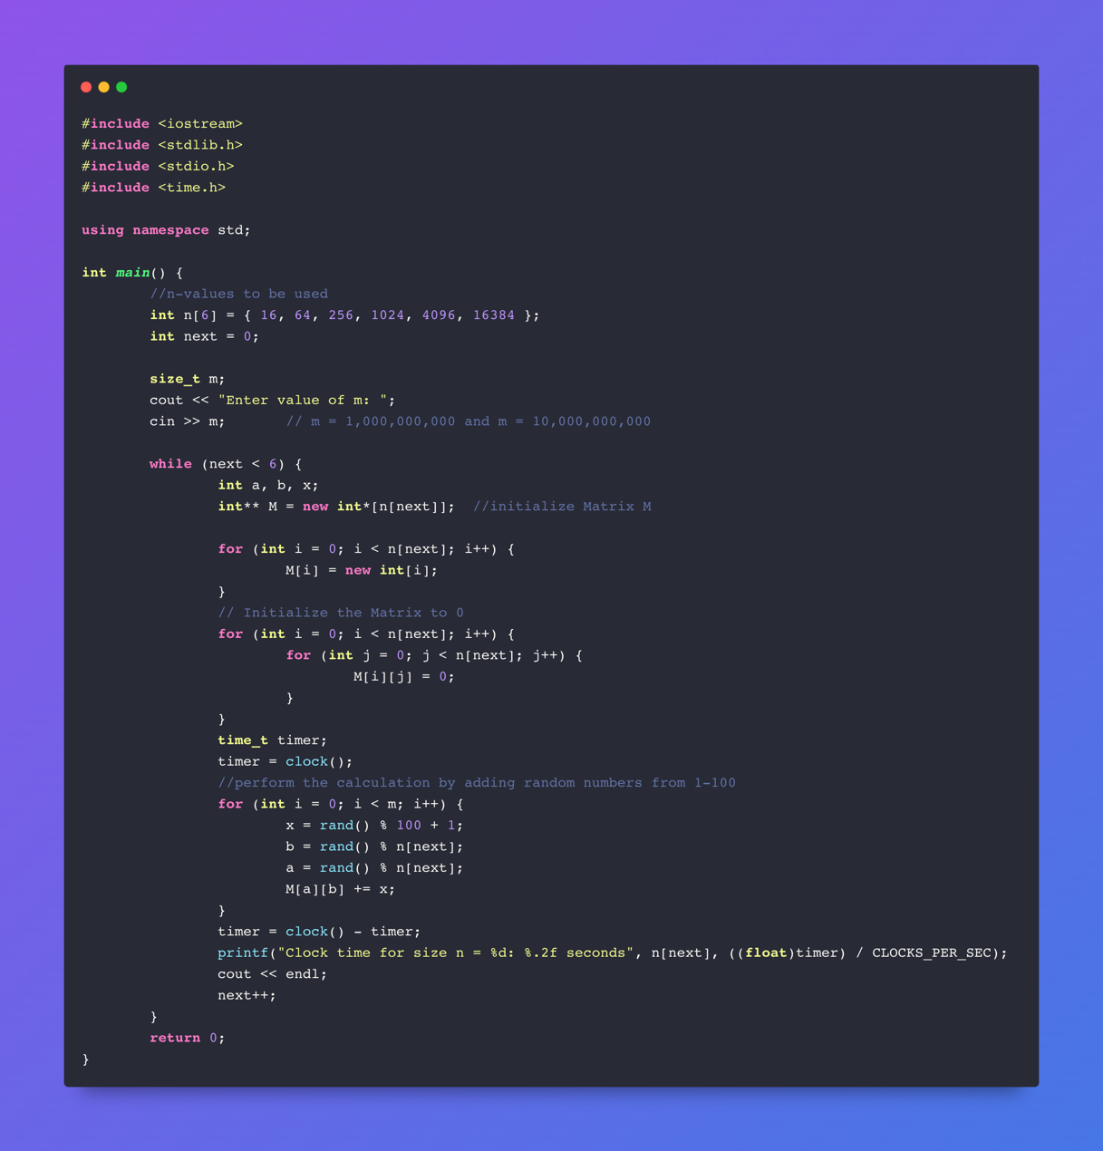

Output:

|  |  |
| --- | --- |
| m = 1 000 000 000 | m = 10 000 000 000 |
|  |  |

For the first 3 runs, the calculation time is approximately the same for each value of m. This shows that for small values of n, the calculation time does not vary regardless of the size of the matrix or the value of m (the number of calculations). However, starting from n = 1024, the calculation time started to increase for each value of m. The reason for that is, with small values of n, the physical memory was sufficient to run the calculations. But, for n = 1024 and larger, the matrix is large enough that the physical memory was not enough to run the calculations.

1. **AVL Trees**

Code:

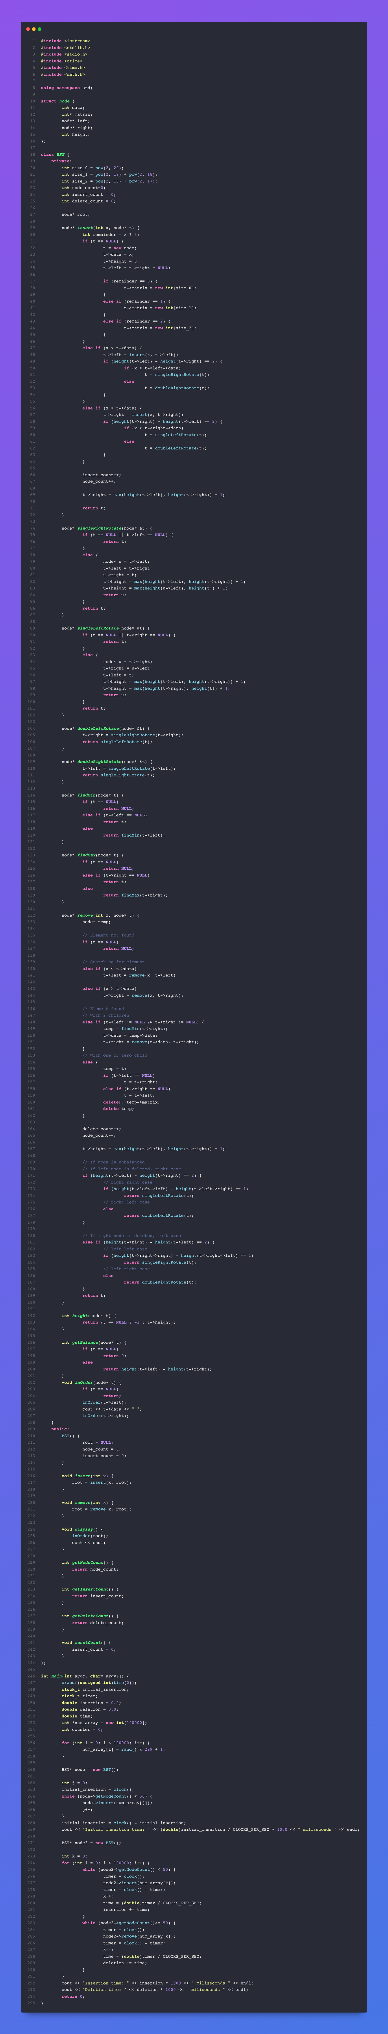

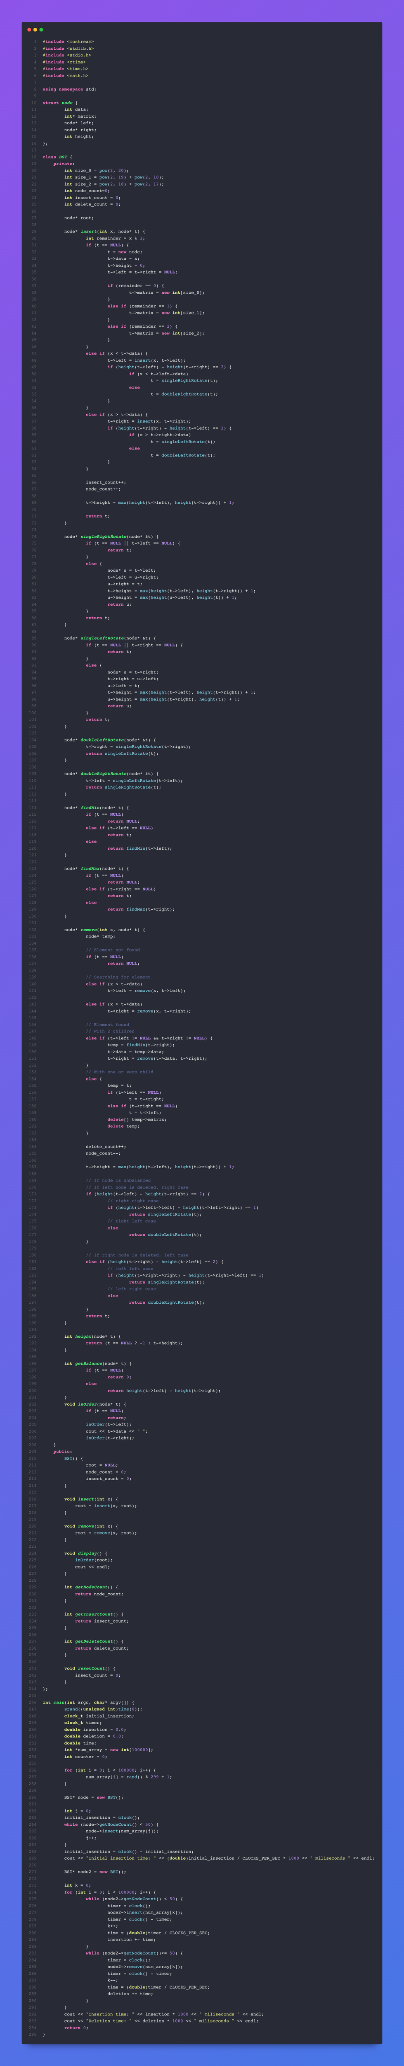

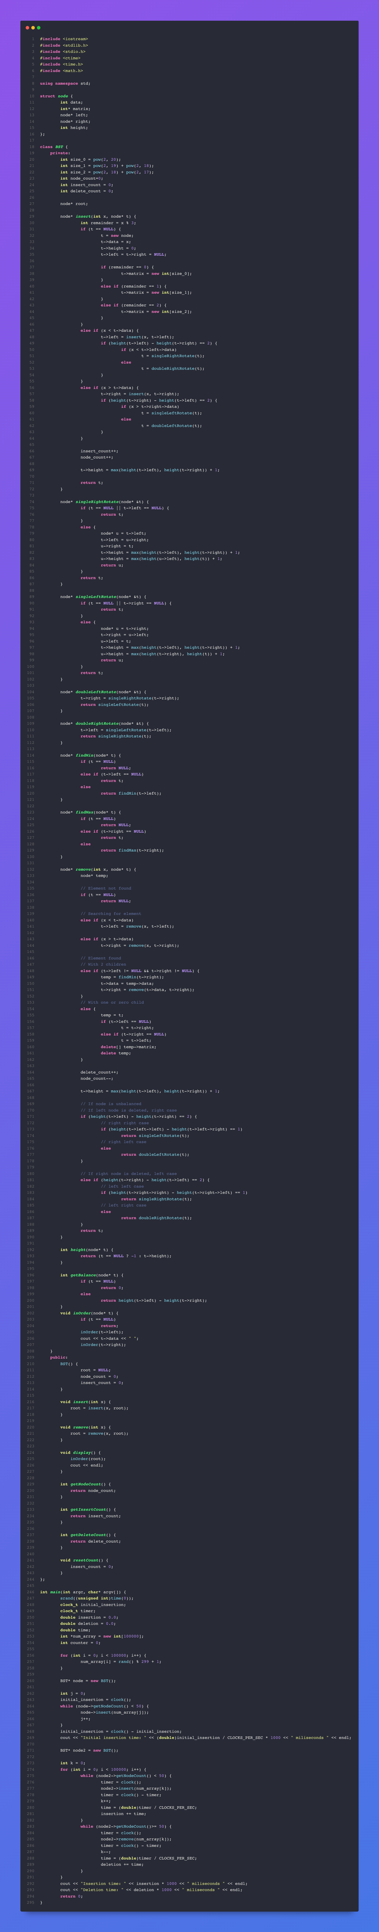

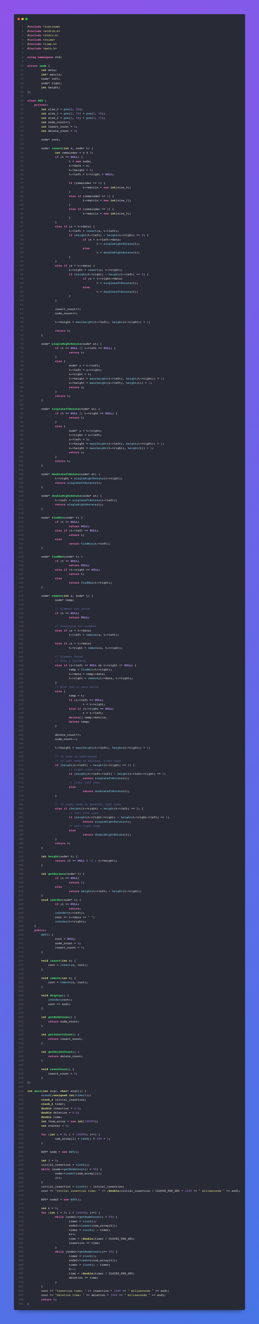

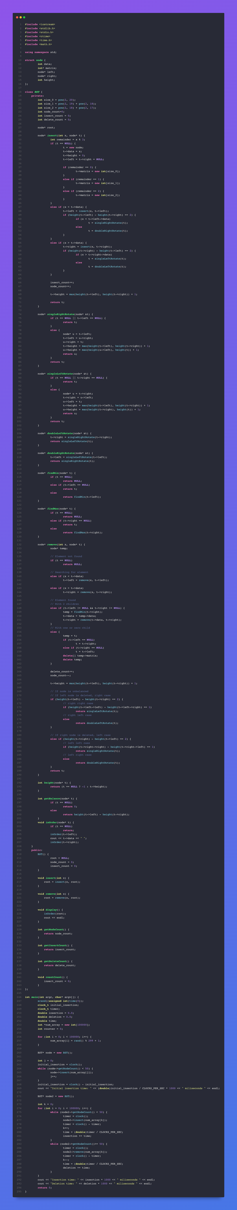

Output:

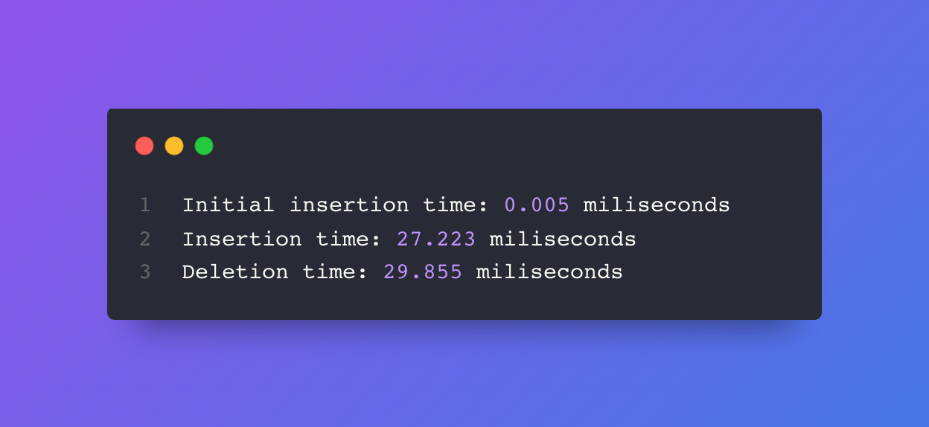

The Initial Insertion time represents the time to insert the first 50 nodes into the tree. The insertion/deletion time is then the average time to insert/delete one node into/from the tree. Once the program started deleting/inserting nodes from the tree, it should result in memory fragmentations and therefore engage memory compaction to close the gaps in memory. That is why the insertion time when the program started inserting/deleting nodes should be higher than the initial insertion time. The deletion times and the insertion times are not significantly different from each other.

1. **Virtual memory management**

Code:

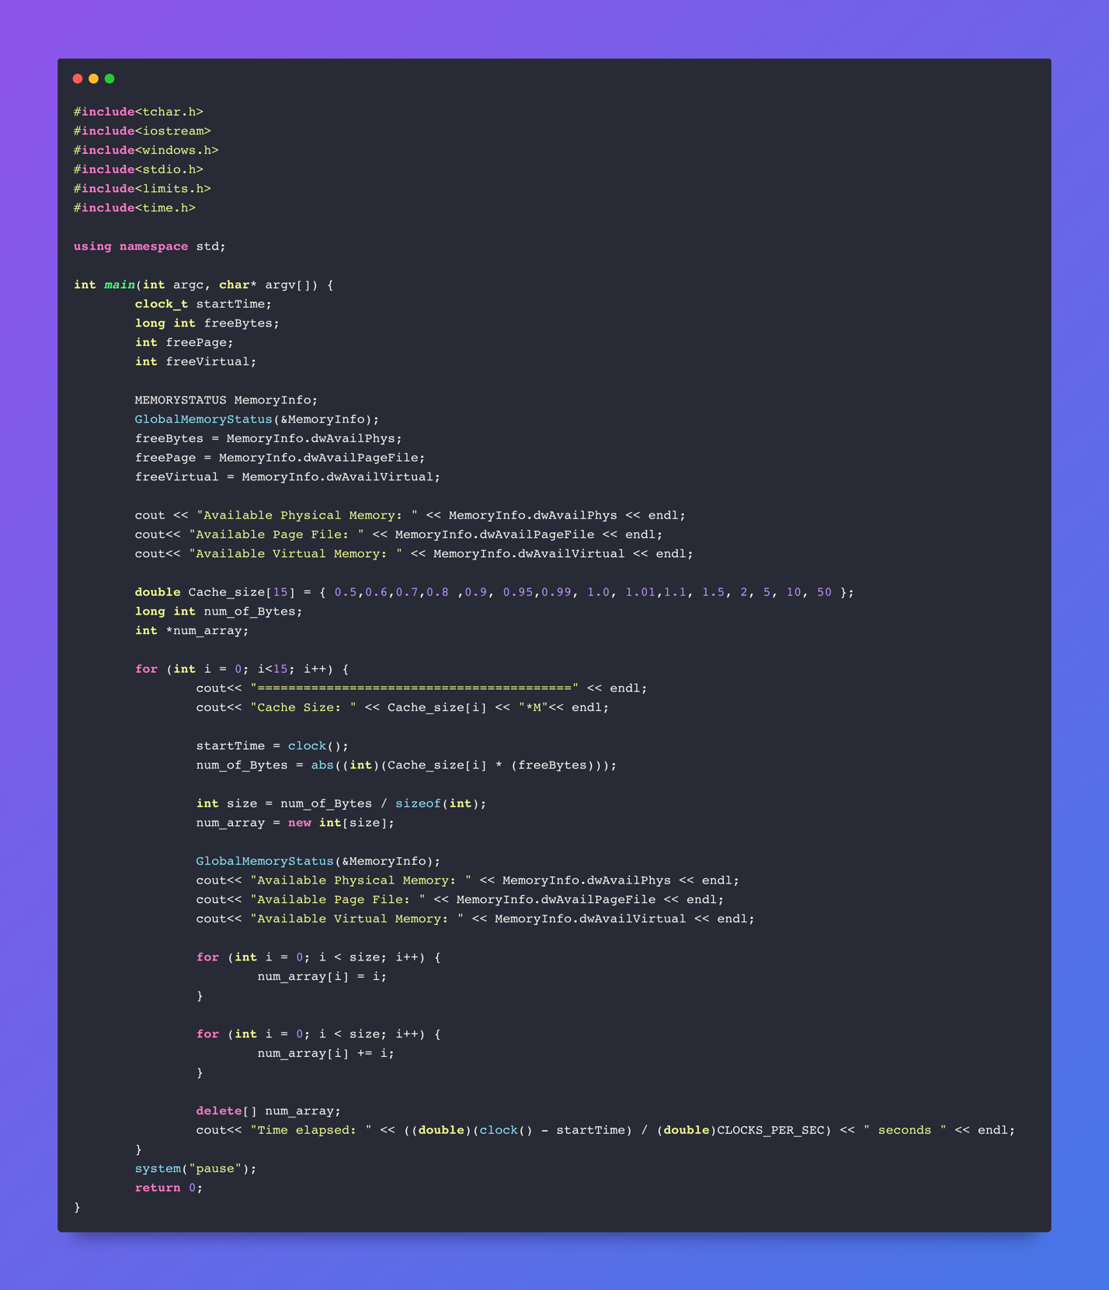

Output:

|  |  |
| --- | --- |
|  | For Cache size = 0.5M to 1M, it looks like that there is not a huge difference in the computation times. However, if we go beyond that point, the time starts increasing significantly. Unfortunately, from cache size = 2M, the program crashed, since my laptop couldn’t handle the computations due to the lack of memory. |